Valuable Patents

Patentics专利检索分析报告

patentics.com

2017/2/8

.Modern Patent Analytics at your fingertips
目录

Electroluminescent device with modified thin film luminescent zone 2
Process for amplifying nucleic acid sequences 5
主权项修订统计 10

Electroluminescent device with modified thin film luminescent zone

公开号 | US4769292 | 公开日 | 1988/09/06
申请号 | 07/108,342 | 申请日 | 1987/10/14
授权日 | 1988/09/06 | 优先日 | 1987/03/02
申请人 | 伊斯曼柯达 | 标准 申请人 | 伊斯曼柯达
专利权人 | 伊斯曼柯达 | 发明人 | Tang; Ching W. | Chen; Chin H. | Goswami; Ramanuj
国际 主分类 | H01L 51/05 | 优先 国家 | US
代理 | Thomas; Carl O.

价值谱 | v1:200  v2:98  v3:9582 | 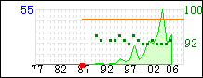 | 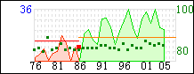
 |  | 主谱 | 参考谱:4,876,356

摘要 | 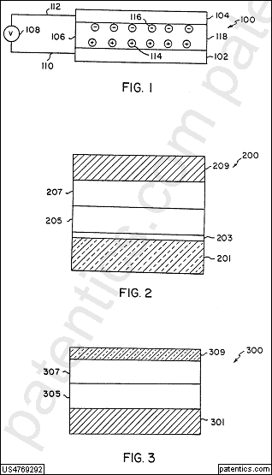
An electroluminescent device is disclosed having a luminescent zone of less than one μm in thickness comprised of an organic host material capable of sustaining hole-electron recombination and a fluorescent material capable of emitting light in response to energy released by hole-electron recombination.

主权项 | 专利度:19  特征度:20 | 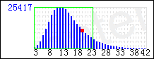
 |  | icl/H01L db/uspat

An organic electroluminescent device comprising in sequence, an anode, an organic hole injecting and transporting zone, a luminescent zone, and a cathode,
characterized in that
said luminescent zone is formed of a thin film of less than 1 μm in thickness comprised of
an organic host material forming a layer capable of sustaining both hole and electron injection and
located in said layer as a fluorescent material a dye capable of emitting light in response to hole-electron recombination, said dye having a bandgap no greater than that of said host material and a reduction potential less negative than that of said host material.

被引用 | 5586 | 自引用 | 1498 | 公司数 | 249 | 国家数 | 8 | 影响数 | 3130.88

同族数 | 8 | 国家数 | 6

法律 状态 | 无效

Process for amplifying nucleic acid sequences

公开号 | US4683202 | 公开日 | 1987/07/28
申请号 | 06/791,308 | 申请日 | 1985/10/25
授权日 | 1987/07/28 | 优先日 | 1985/03/28
申请人 | 塞特斯公司 | 标准 申请人 | 塞特斯公司
专利权人 | roche molecular systems | 发明人 | Mullis; Kary B.
国际 主分类 | C12Q 1/68 | 优先 国家 | US
代理 | Hasak; Janet E. Halluin; Albert P.

价值谱 | v1:200  v2:100  v3:300 | 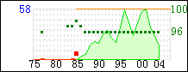 | 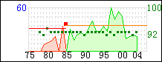
 |  | 主谱 | 参考谱:4,767,711

摘要 | 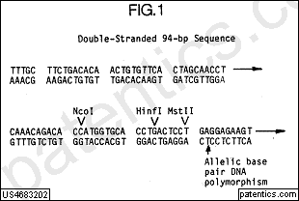
The present invention is directed to a process for amplifying any desired specific nucleic acid sequence contained in a nucleic acid or mixture thereof. The process comprises treating separate complementary strands of the nucleic acid with a molar excess of two oligonucleotide primers, and extending the primers to form complementary primer extension products which act as templates for synthesizing the desired nucleic acid sequence. The steps of the reaction may be carried out stepwise or simultaneously and can be repeated as often as desired.

主权项 | 专利度:21  特征度:23 | 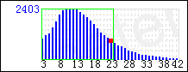
 |  | icl/C12Q db/uspat

A process for amplifying at least one specific nucleic acid sequence contained in a nucleic acid or a mixture of nucleic acids wherein each nucleic acid consists of two separate complementary strands, of equal or unequal length, which process comprises:
(a) treating the strands with two oligonucleotide primers, for each different specific sequence being amplified, under conditions such that for each different sequence being amplified an extension product of each primer is synthesized which is complementary to each nucleic acid strand, wherein said primers are selected so as to be sufficiently complementary to different strands of each specific sequence to hybridize therewith such that the extension product synthesized from one primer, when it is separated from its complement, can serve as a template for synthesis of the extension product of the other primer;
(b) separating the primer extension products from the templates on which they were synthesized to produce single-stranded molecules; and
(c) treating the single-stranded molecules generated from step (b) with the primers of step (a) under conditions that a primer extension product is synthesized using each of the single strands produced in step (b) as a template.

被引用 | 55338 | 自引用 | 63 | 公司数 | 4681 | 国家数 | 10 | 影响数 | 45142.98

同族数 | 113 | 国家数 | 18

法律 状态 | 无效

 | 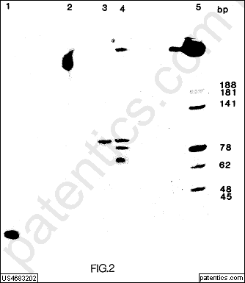
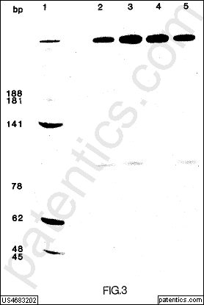 | 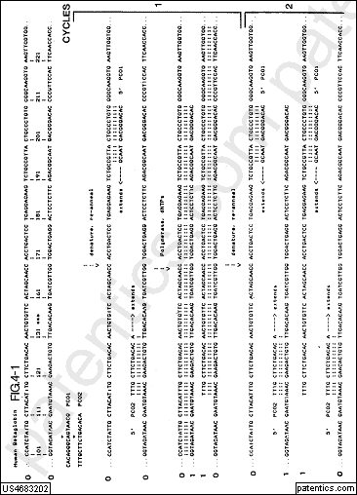
 | 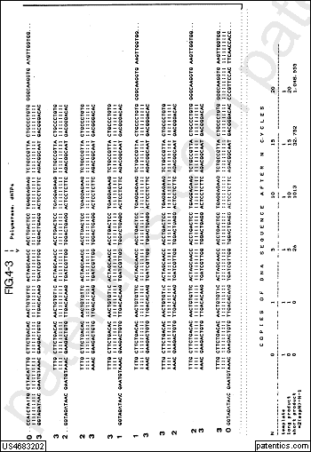
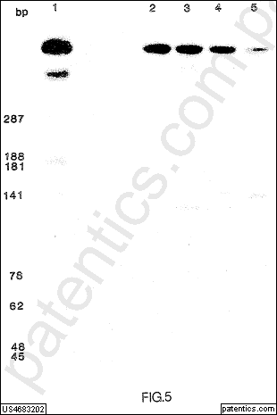 | 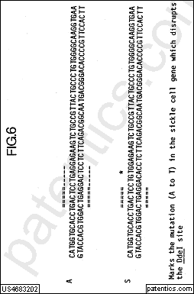
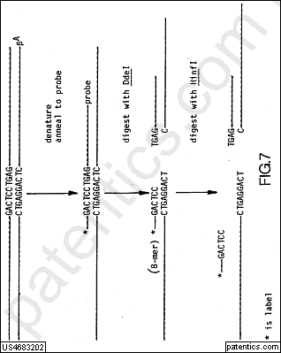 | 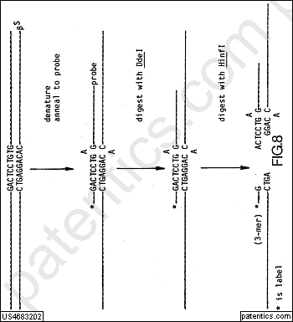
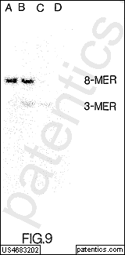 | 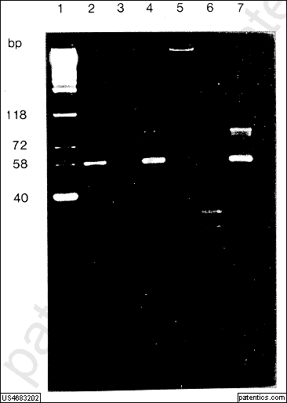

主权项修订统计

总计2篇；
无对比2篇
对比0篇
- 主权项修订0篇；
- 主权项插入0处；
- 主权项删除0处；
- 主权项保留0处；
- 主权项无修订0篇。

